[Your institutional letterhead here]
TO: [INSERT NAME]
FROM: [INSERT YOUR NAME]
DATE: [INSERT DATE]
SUBJECT: Individual Learner Request to Attend the 2023 National Inclusive Excellence Leadership Academy (NIXLA) Accelerator Series Summer Program

Please find below a formal request for funding to support my attendance in the 2023 National Inclusive Excellence Leadership Academy (NIXLA) Accelerator Series program, a virtual institute taking place July 6-27.

The Academy’s curriculum is designed to be highly interactive and practical, focusing on setting goals that align with our own mission and strategic priorities. [Include the following sentence if you are requesting funding for the complete, seven-part Accelerator series:] During the program, I will be provided with individual coaching from experts in the field and supported to enhance my strategic DEI leadership skills and abilities.
Appended to this proposal is: (1) The NIXLA Accelerator Series program brochure and (2) An overview presentation with more details about the program. Complete details can be found at https://bit.ly/NIXLA2023.
WHAT IS NIXLA?

NIXLA is an online strategy and leadership development program taking place over four weeks. It is specifically designed for those who want to level up their institutional DEI strategy while simultaneously improving their individual leadership skills and understanding. This evidence-based program is led by Dr. Damon A. Williams, noted author of the best-selling Strategic Diversity Leadership: Activating Change and Transformation in Higher Education, co-author of the Chief Diversity Officer: Strategy, Structure, and Change Management, and one of the original architects of the Inclusive Excellence concept that began in American higher education.

The NIXLA Accelerator Series summer program will cover current topics including navigating pressing anti-DEI legislative dynamics; understanding the differences between antiracism and DEI approaches to strategic planning and change management; cancel culture and generational differences among gen Z, millennials, and older generations, particularly in the backwash of DEI crises and flashpoints; the important role of allyship in the academy; implementing DEI efforts across schools, colleges, and administrative divisions and units; Inclusive Excellence in the classroom; best practices for assessing campus climate and DEI implementation; and steps to ensure that [insert your institution’s name] benefits from the DEI commitments that we have already made by creating a stronger culture of accountability, risk mitigation, and assessment as a foundation of our DEI efforts.

MY NIXLA EXPERIENCE

The National Inclusive Excellence Leadership Academy is the industry leader in terms of qualification in strategic DEI leadership. [Include the following sentence if you are requesting funding for the complete, seven-part Accelerator series:] By completing the entire seven-part virtual series, I will earn a certificate of completion, digital badging, and membership in the NIXLA alumni community, a national network of
DEI leaders.

I am specifically excited by [insert the topic(s) that excite you] that is offered during the summer. This/these topics build from the work we have been doing in [insert the relevant committee, unit, or project]. Specifically, these accelerator sessions will allow me to ground myself in the principles of [insert relevant principles and/or concepts for your institution/school/college/division/unit] while working to build a more nuanced understanding towards applying these ideas during the 2023/2024 academic year and beyond.
[For your reference while completing this section of the template, copied below are the (seven) Accelerator session names/numbers. If you are not requesting funding for the complete series, remember to delete any sessions that you will not attend.]
I propose to attend the following sessions:
- Session 1—DEI Update: Navigating the Current Strategic DEI Environment and Anti-DEI Legislative Dynamics, 7/6/2023
- Session 2—Strategic Planning Fundamentals of Success: Integrated Approaches; DEI vs. Antiracism Change Processes; and Building Engagement and Accountability, 7/11/2023
- Session 3—Implementation: Leading DEI Change Efforts in Higher Education, including Athletics, Student Affairs, and Other Administrative Units, 7/13/2023
- Session 4—Strategic DEI Leadership: Strategies and Tips for Thriving in a CDO or DEI Officer Role, 7/18/2023
- Session 5—Avoiding Performative Climate Studies: Best Practices for Gathering and Utilizing Data to Disrupt a Culture of Microaggression and Othering, 7/20/2023
- Session 6—Pedagogy & Inclusive Excellence in the Classroom: Strategies for Faculty & Teachers to Elevate and Foster DEI, 7/25/23
- Session 7—From Bystander to Upstander: The Ally’s Journey through Antiracism, Diversity, Equity, and Inclusion, 7/27/2023
Benefits of the NIXLA Accelerator Series include:
- I will be exposed to a range of best practices, research data, and case studies in diversity, equity, and inclusion, all of which, along with the session recordings, will be available days after the program ends, for my review.

- The NIXLA experience facilitates strategic relationships and networking with counterparts from higher education institutions across the country, providing an opportunity for me to learn from leaders from other institutions and to build ongoing partnerships in this area.

- Attending NIXLA will enhance my strategic diversity leadership skills and represents a tangible contribution to my professional development.

- All of the knowledge and skills acquired in NIXLA will be immediately applicable to our current diversity, equity, and inclusion projects and initiatives, such as [insert examples here].

- I would also offer to lead a post-Academy presentation for interested colleagues, to pass on best practices and lessons learned.

As we look to the 2023/2024 academic year and beyond, I am confident that this investment in NIXLA will be incredibly valuable to our DEI efforts moving forward.

COST AND TIME FRAME

This proposal is for funding to cover the individual course fee of [insert total cost of your academy experience $XXXX]. This fee includes the cost of [insert number of sessions] live master-class-format virtual Accelerator sessions with breakout discussions, resources, instruction, coaching, and digital leadership tools for the program. No travel, accommodation, or other expenses are required.

During the Academy’s program, from July 6 to 27, 2023, a minimum commitment of 3-6 hours per week will be required from all participants in order to attend online lectures, coaching, and discussions. Please know that I am fully committed to balancing these requirements with my regular responsibilities and duties. [Provide further details about how this will be achieved, which may include requesting a flexible workday once per week during the program, securing support from colleagues and/or department, or preparing for certain key tasks in advance].
Thank you for considering this request. Should you require any additional information relevant to my application, please do not hesitate to let me know.

APPENDIX 1: NIXLA PROGRAM BROCHURE

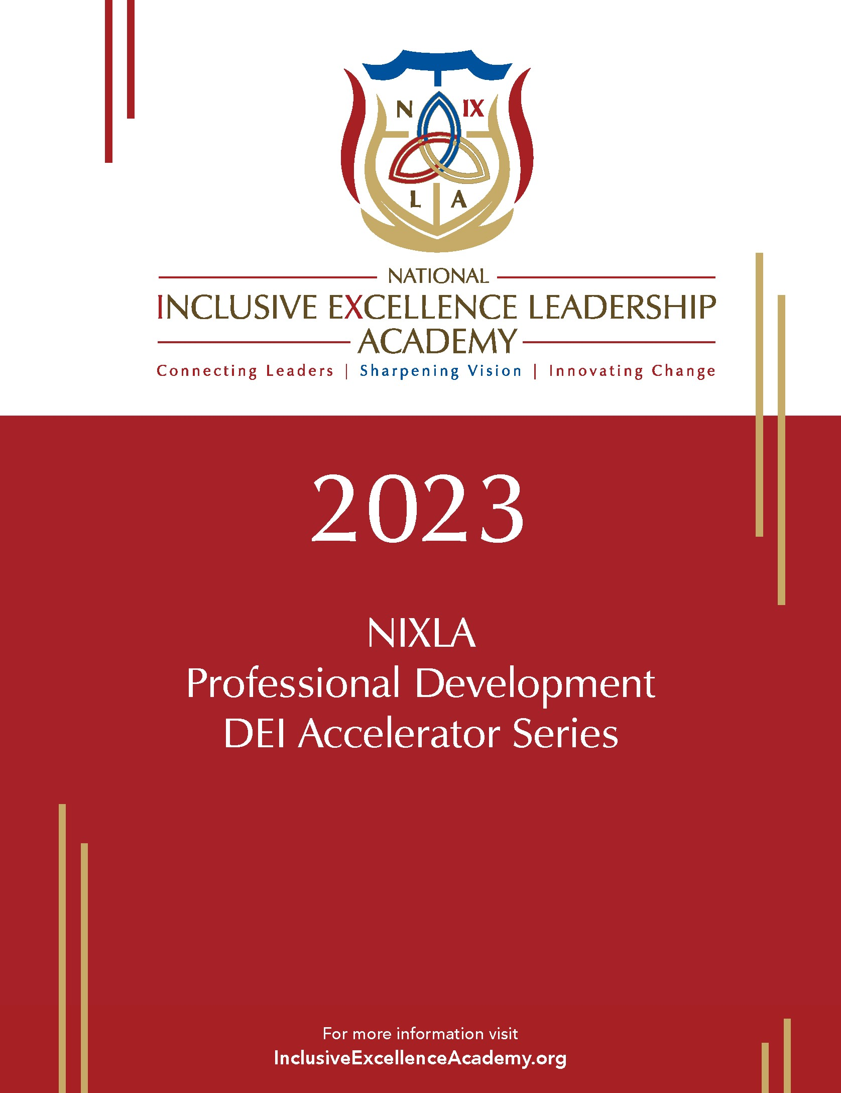
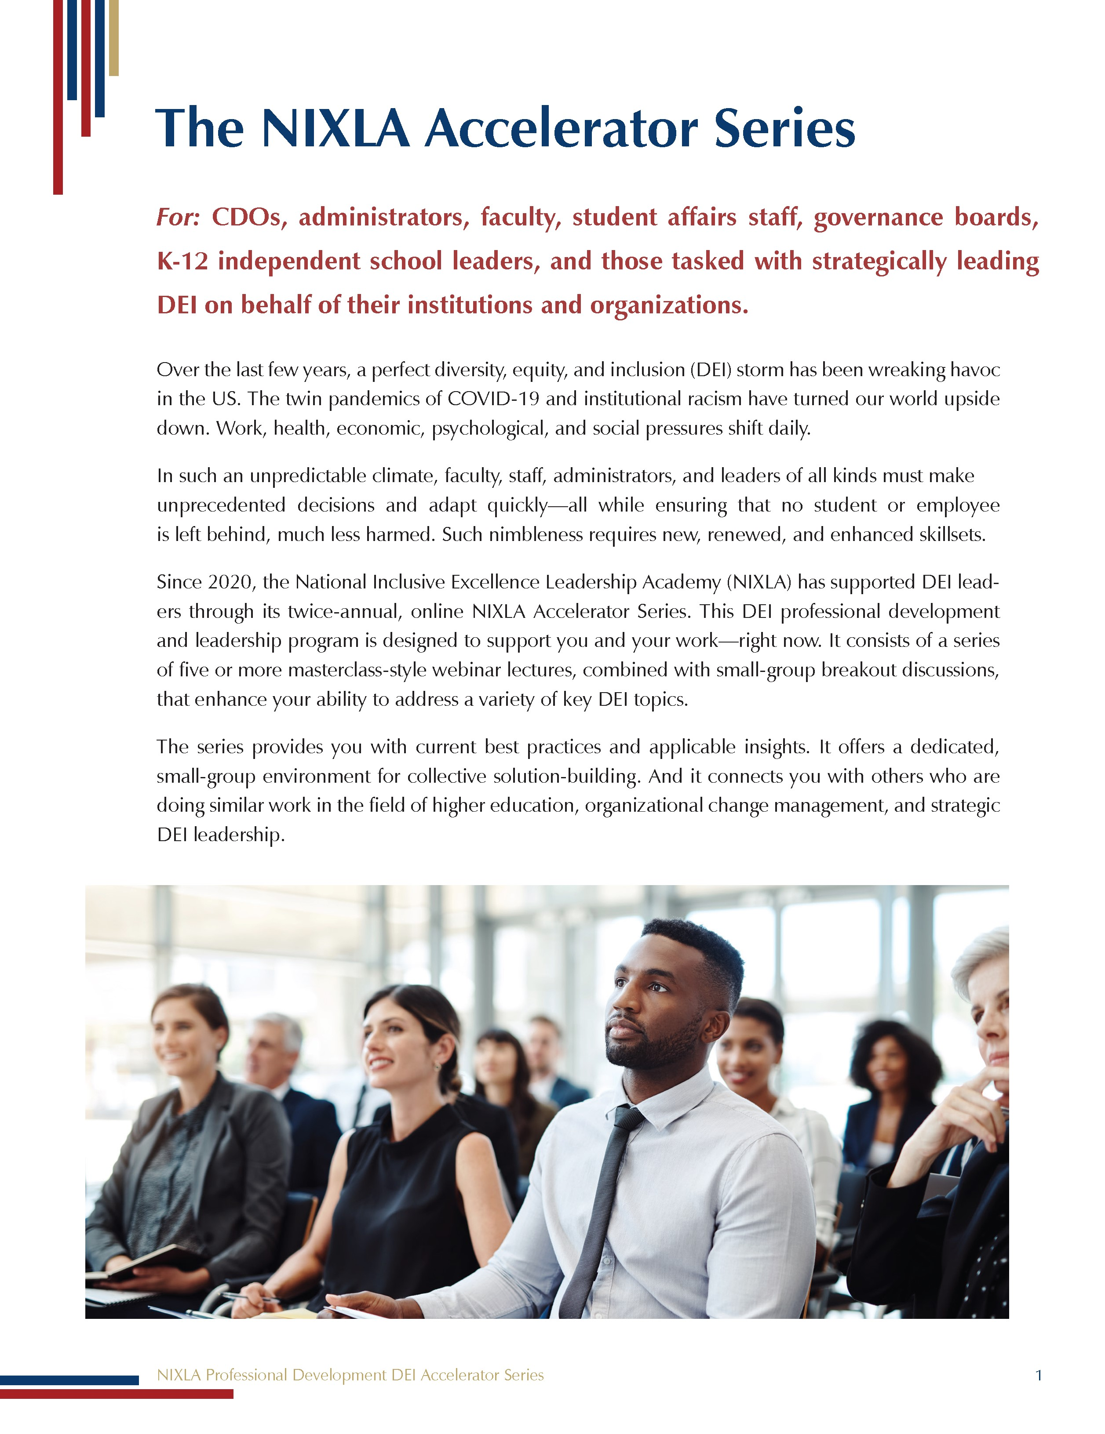
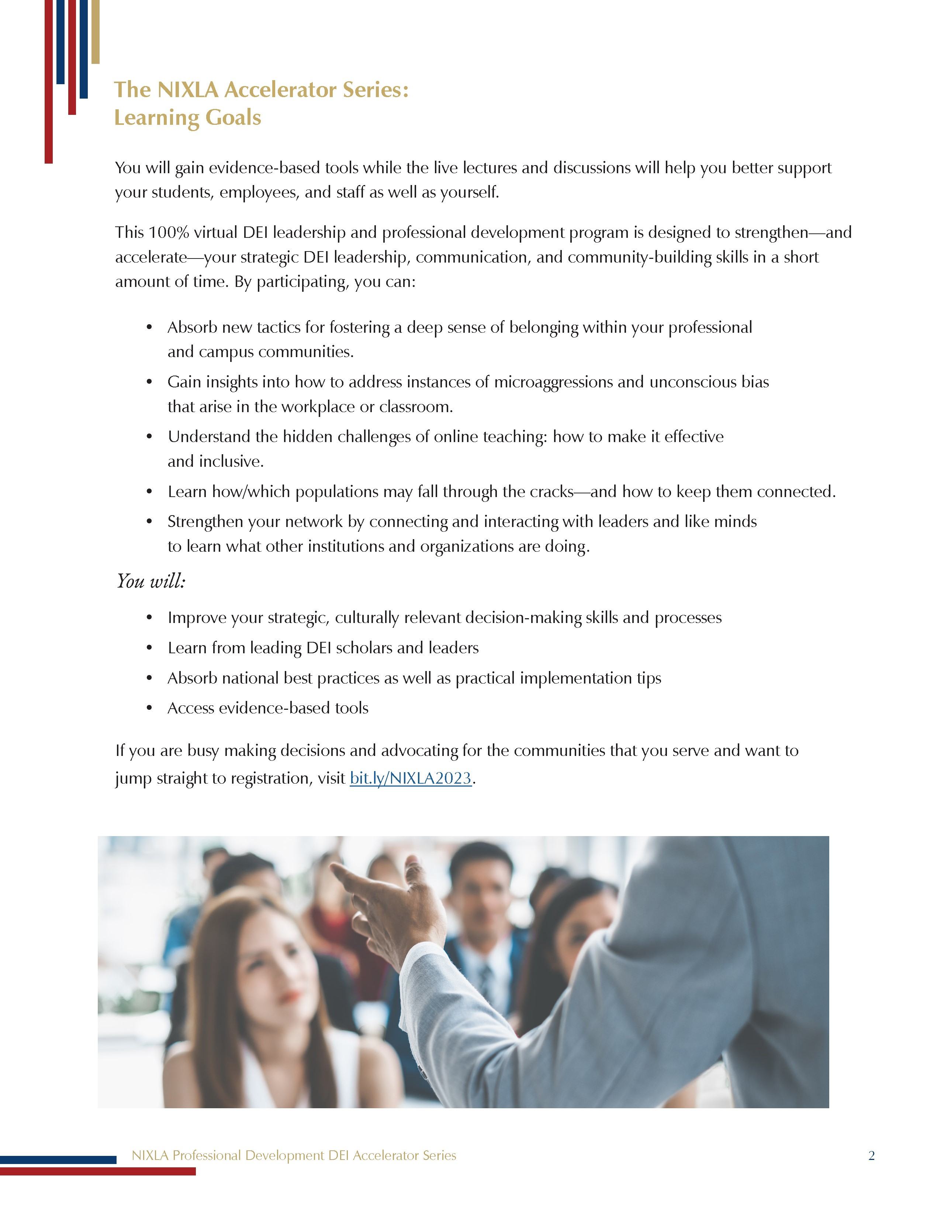
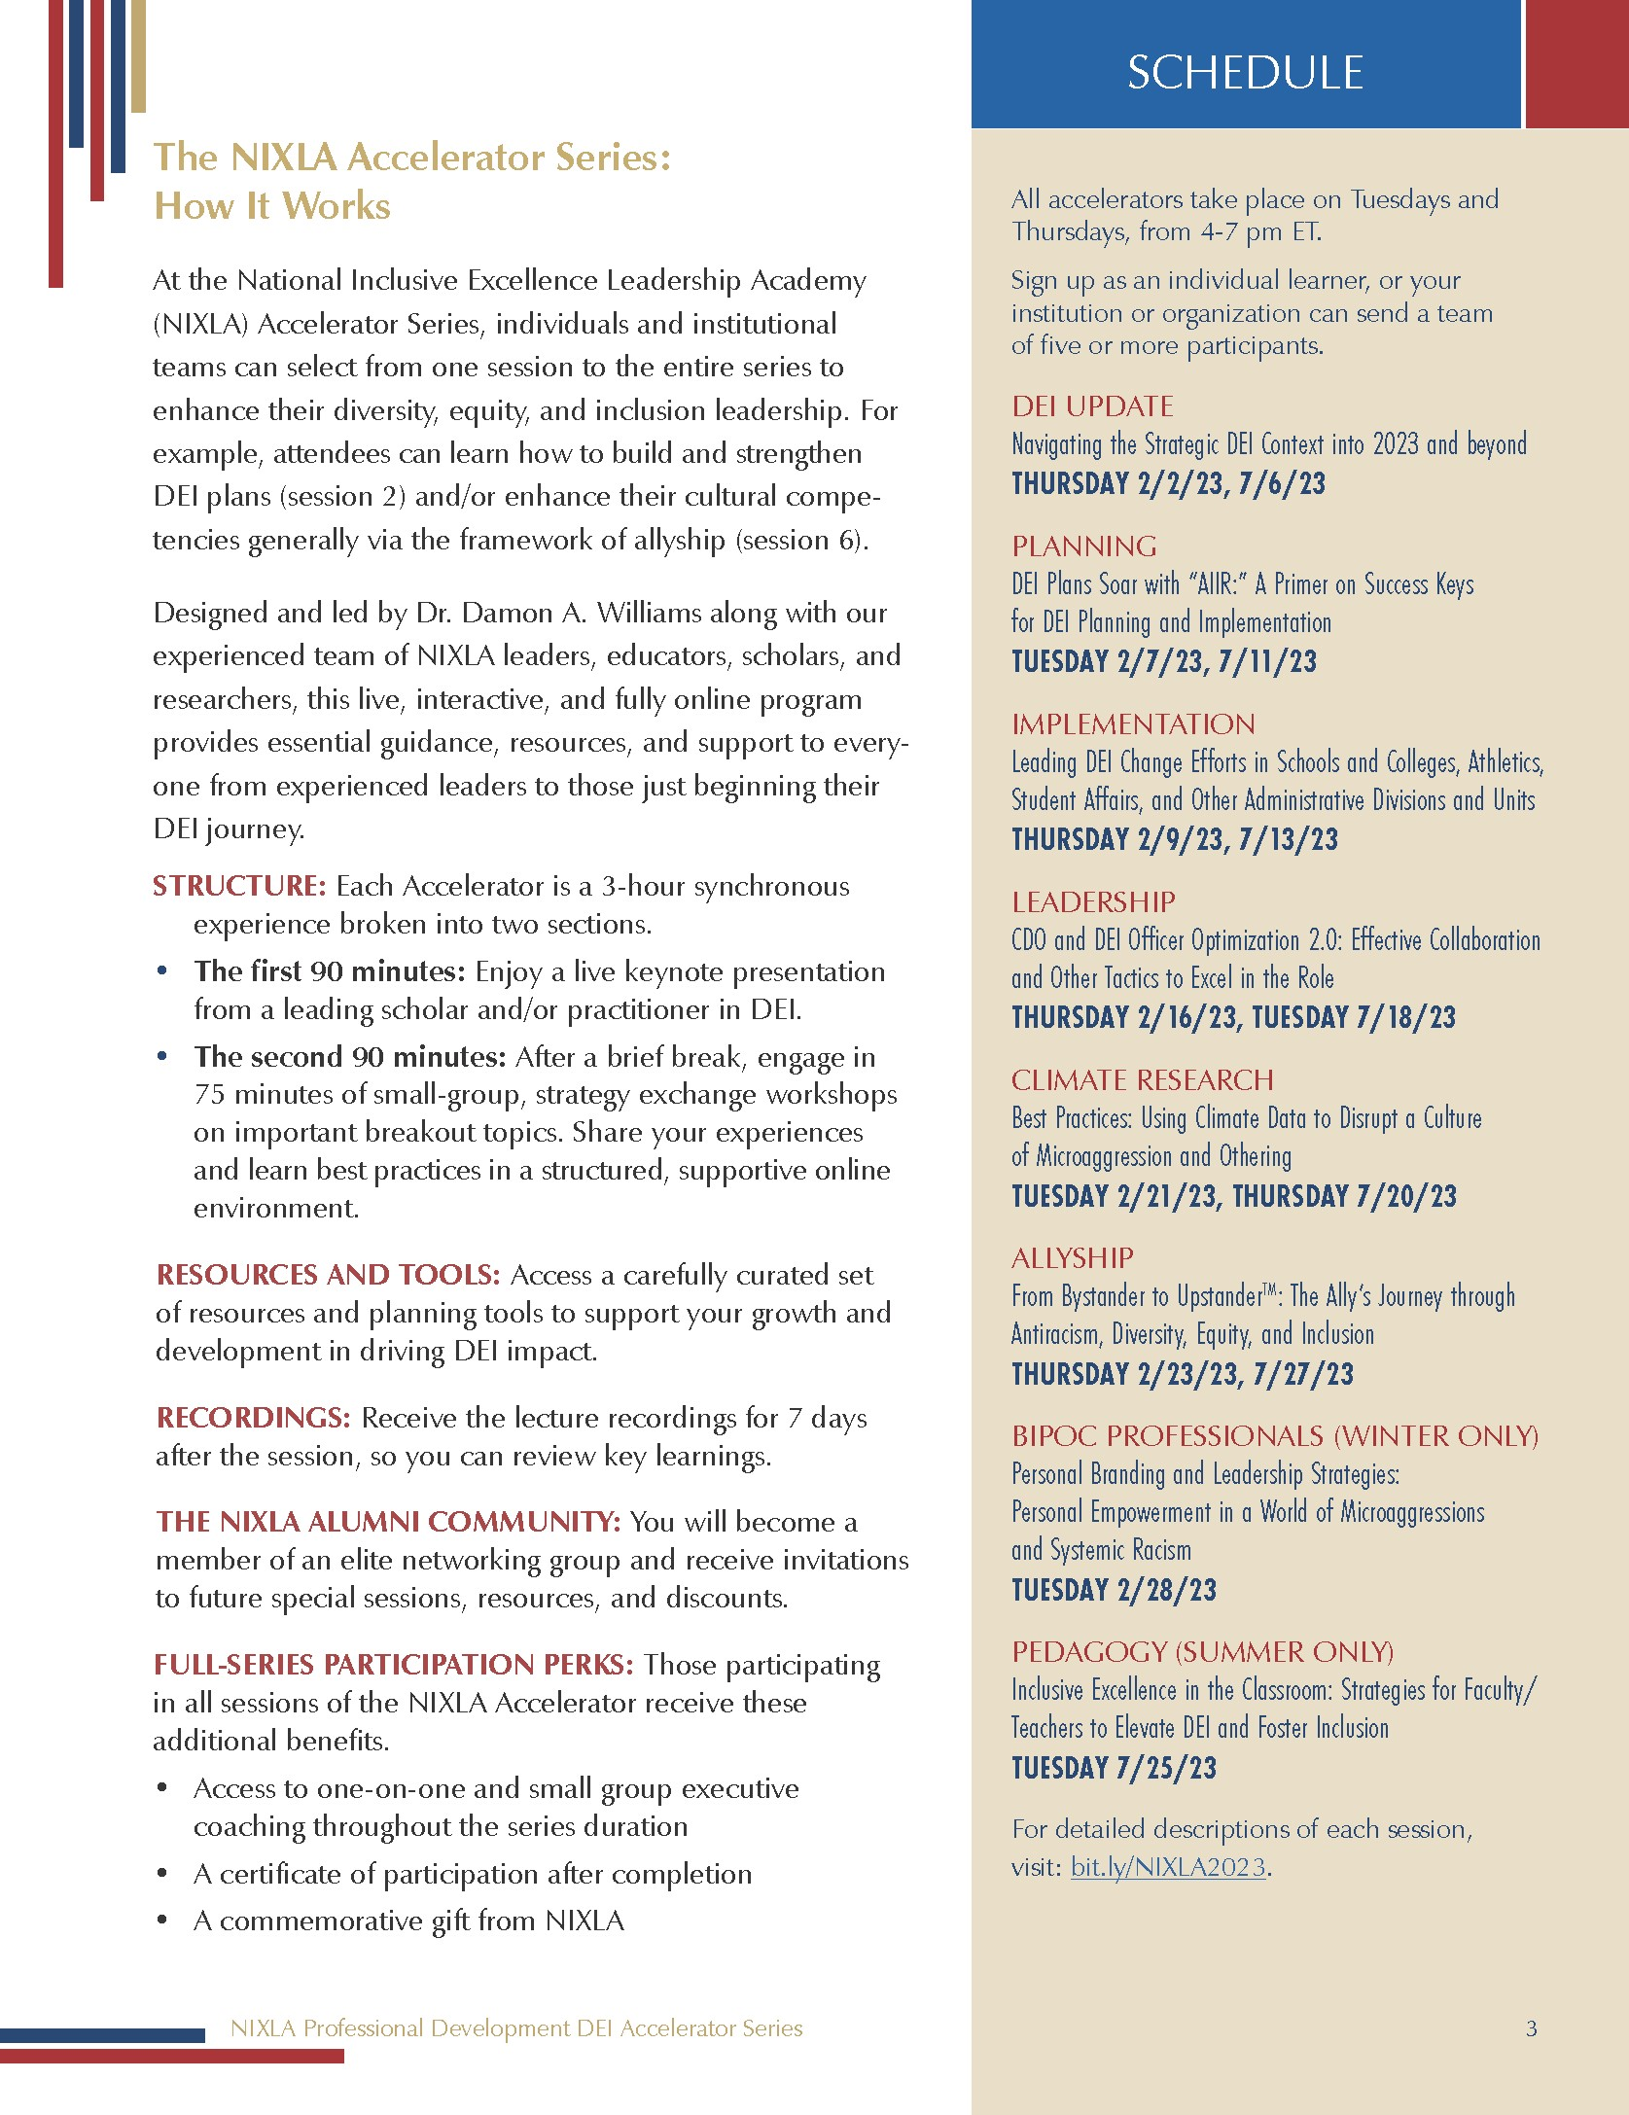
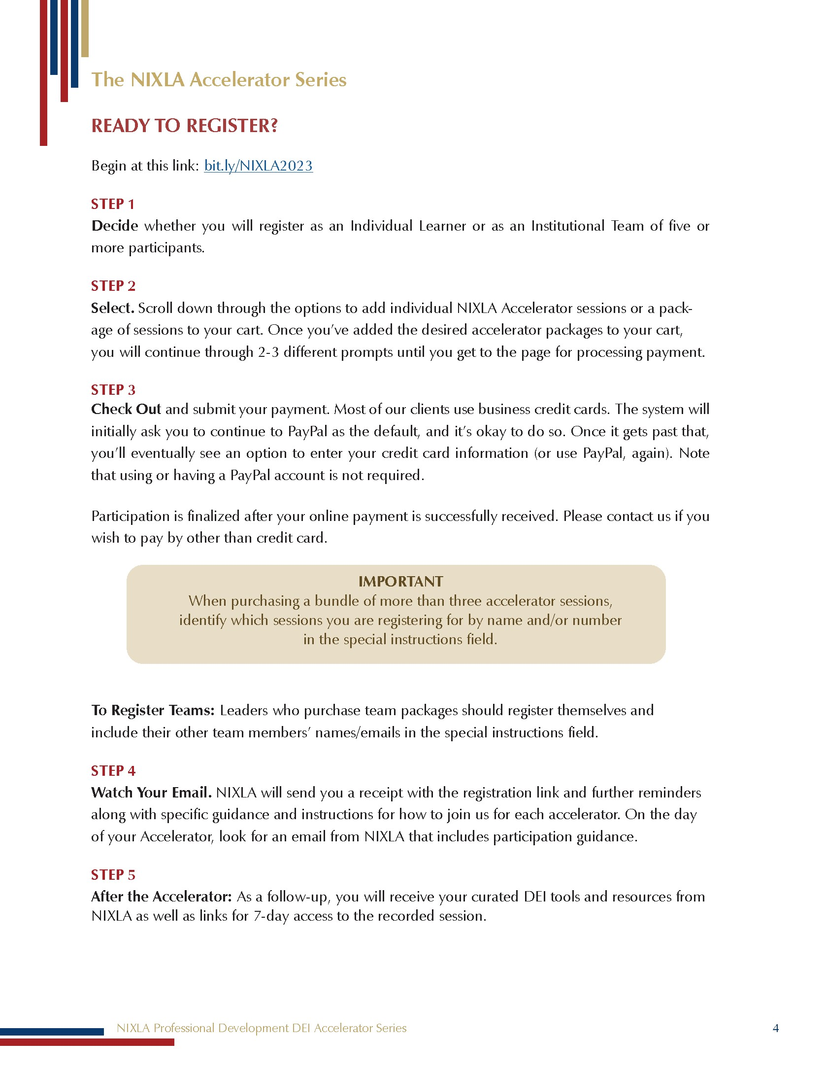
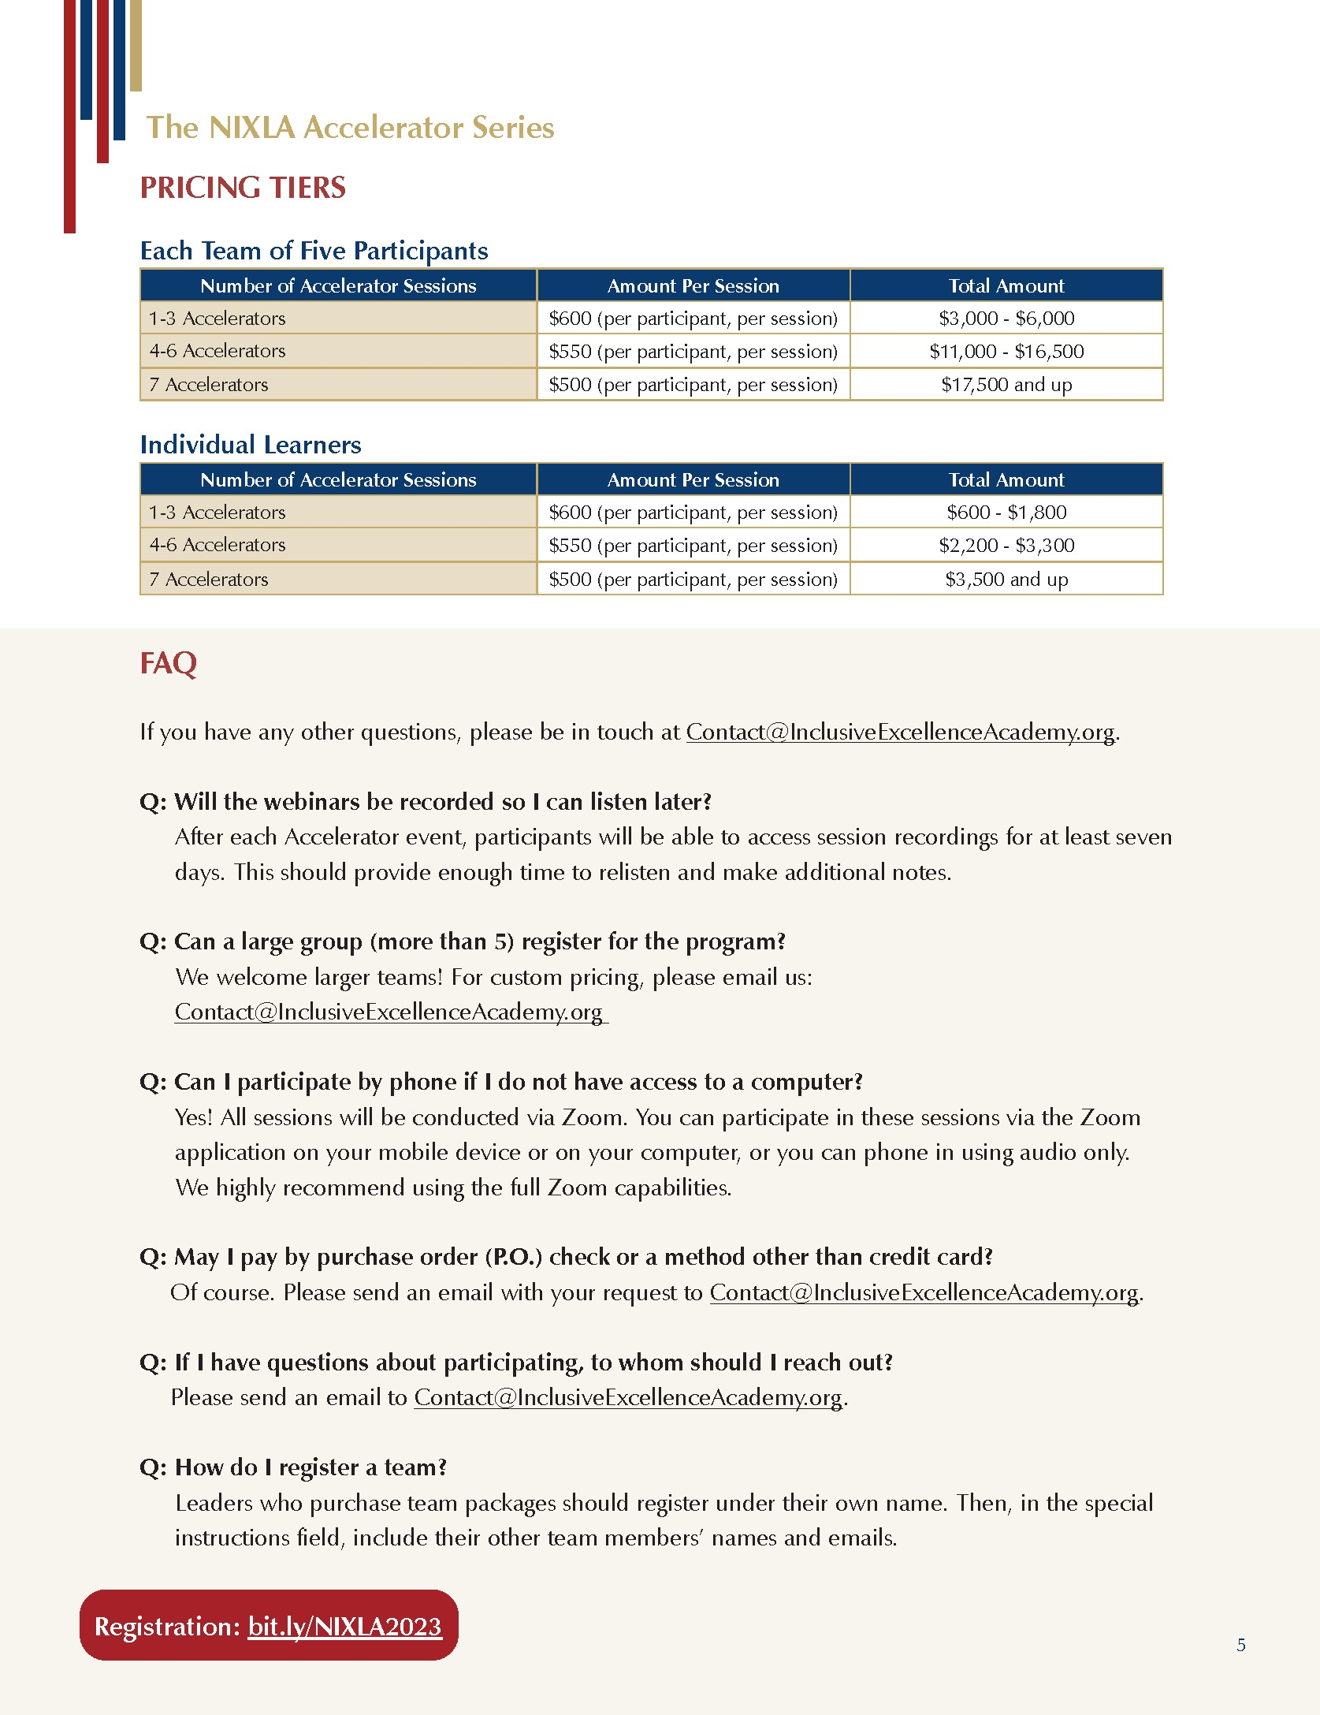
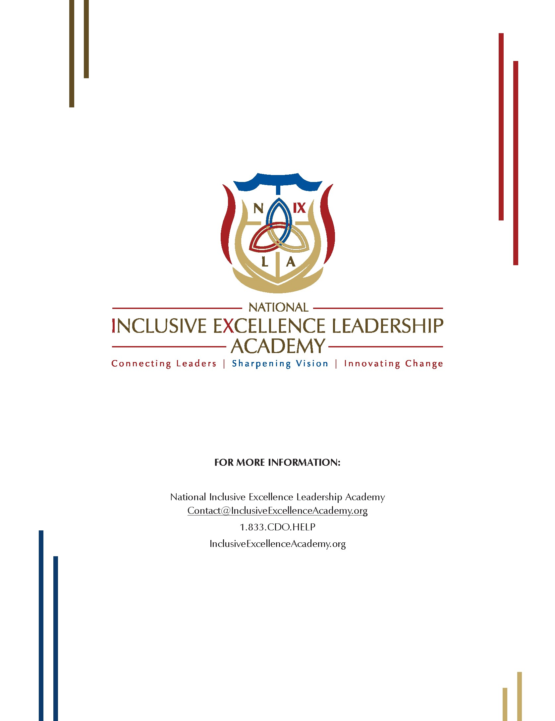

APPENDIX 2: NIXLA INFORMATIONAL SLIDES
