[Your institutional letterhead here]

TO: [INSERT NAME]
FROM: [INSERT YOUR NAME]
DATE: [INSERT DATE]
SUBJECT: Team Request to Attend the 2023 National Inclusive Excellence Leadership Academy (NIXLA) Accelerator Series Summer Program

Please find below a formal request for funding to support a five-person team to attend the 2023 National Inclusive Excellence Leadership Academy (NIXLA) Accelerator Series Program, a virtual institute taking place July 6-27, with opportunities for continuing consultations through the end of August.

The Academy’s curriculum is designed to be highly interactive and practical, focusing on setting goals that align with our own mission and strategic priorities.

Enclosed in this proposal is (1) The program brochure and (2) An overview presentation with more details about the program. Complete details can be found at https://bit.ly/NIXLA2023.

WHAT IS NIXLA?

NIXLA is an online strategy and leadership development program taking place over four weeks. It is specifically designed for those who want to level up their institutional DEI strategy while simultaneously improving their individual leadership skills and understanding. This evidence-based program is led by Dr. Damon A. Williams, noted author of the best-selling Strategic Diversity Leadership: Activating Change and Transformation in Higher Education, co-author of the Chief Diversity Officer: Strategy, Structure, and Change Management, and one of the original architects of the Inclusive Excellence concept that began in American higher education.

The NIXLA Accelerator Series summer program will cover current topics including navigating pressing anti-DEI legislative dynamics; understanding the differences between antiracism and DEI approaches to strategic planning and change management; cancel culture and generational differences among gen Z, millennials, and older generations, particularly in the backwash of DEI crises and flashpoints; the important role of allyship in the academy; implementing DEI efforts across schools, colleges, and administrative divisions and units; Inclusive Excellence in the classroom; best practices for assessing campus climate and DEI implementation; and steps to ensure that [insert your institution’s name] benefits from the DEI commitments that we have already made by creating a stronger culture of accountability, risk mitigation, and assessment as a foundation of our DEI efforts.

NIXLA Accelerator Series Program Benefits

Benefits of the NIXLA Accelerator Series include:

- NIXLA faculty will support our team’s ability to get off to a fast start for the 2023-24 academic year. The program allows us to have dedicated time and space to advance [insert the name of your institution/university/school/college/division/unit] DEI priorities over the summer with guidance and support from experienced leaders in higher education.

- We will be exposed to a range of best practices, research data, and case studies in diversity, equity, and inclusion, all of which, along with the learning videos, will be available several days after the program ends, for our review.

- Our team will develop deeper working relationships among our members, enhancing our work at [institution/university/school/college/division/unit] going forward.

- The Academy experience facilitates strategic relationships and networking opportunities (including breakout discussions) with counterparts from higher education institutions across the country, providing an opportunity for us to learn from others and to build ongoing partnerships in this area.

- Attending will enhance the strategic diversity leadership skills of each team member, representing a tangible contribution to their professional development, specifically in relation to [insert relevant topic area for your institution]. Attending as a team will build strong, cohesive leadership to steward our ongoing implementation efforts.

- All of the knowledge and skills acquired will be immediately applicable to our current DEI efforts, such as [insert examples here].

- The team participating in NIXLA is willing to offer a presentation after the completion of the program for interested colleagues at our institution, to pass on best practices, lessons learned, and progress made on our focus project.

The [Insert name of your institution] Team

The team participating in the upcoming NIXLA Accelerator Series will be comprised of the following members of our community:

- [Insert name and position]
- [Insert name and position]
- [Insert name and position]
- [Insert name and position]
- [Insert name and position]

Our team will participate in the following NIXLA Accelerator Virtual Sessions: [For your reference, below are all seven Accelerator session names/numbers. If you are not requesting team funding for the complete series, remember to delete any sessions that your team will not attend.]

- Session 1—DEI Update: Navigating the Current Strategic DEI Environment and Anti-DEI Legislative Dynamics, 7/6/2023
- Session 2—Strategic Planning Fundamentals of Success: Integrated Approaches; DEI vs. Antiracism Change Processes; and Building Engagement and Accountability, 7/11/2023
- Session 3—Implementation: Leading DEI Change Efforts in Higher Education, including Athletics, Student Affairs, and Other Administrative Units, 7/13/2023
- Session 4—Strategic DEI Leadership: Strategies and Tips for Thriving in a CDO or DEI Officer Role, 7/18/2023
- Session 5—Avoiding Performative Climate Studies: Best Practices for Gathering and Utilizing Data to Disrupt a Culture of Microaggression and Othering, 7/20/2023
- Session 6—Pedagogy & Inclusive Excellence in the Classroom: Strategies for Faculty & Teachers to Elevate and Foster DEI, 7/25/23
- Session 7—From Bystander to Upstander: The Ally’s Journey through Antiracism, Diversity, Equity, and Inclusion, 7/27/2023

[If you are planning to request funding for the consulting add-on package include the following section:]

THE NIXLA FOCUS PROJECT EXPERIENCE

NIXLA gives us the opportunity to sponsor a [insert name of your institution] team to not only learn but also work on a specific DEI challenge we face, with support from NIXLA faculty. By participating in the NIXLA Focus Project Experience, our team and a focus project of our choice could be supported by expert coaching, project management tools, advanced content expertise, a structured project planning timeline, and more.

NIXLA faculty will support us in developing an action plan for the 2023-24 academic year regarding our focus project. During the program, our team will be provided with both individual and group coaching from experts in the field. Our team will be well supported as we work together on a specific diversity challenge.

As for the learning opportunity, we are specifically excited by the Accelerator sessions on [insert the topic, or topics that excite you] that NIXLA offers this summer. This/these topics build upon the work we have been doing in [insert the relevant committee, division, unit, or project]. Specifically, these sessions will allow us to ground ourselves in the principles of [insert relevant principles and/or concepts for your institution], while working to build a nuanced understanding of how we can apply these ideas during the 2023/2024 academic year and beyond.

[If you are planning to request funding for the consulting add-on package include the following section:]

The [Insert name of your institution] Team NIXLA Focus Project

It is in this context that we propose to work on the following as our team focus project: [Describe the specific challenge your team will address, for example—building a new DEI strategic framework, developing a staff project that creates a context to discuss antiracism and cancel culture, establishing a new set of questions on generational diversity to add to our upcoming climate and culture study research instrument, developing a plan to inform our community about the anti-DEI legislative movement, etc.]
To receive consulting support for our NIXLA Focus Project, we must register our team for at least four Accelerator sessions and sign up for the consulting add-on.

COST AND TIME FRAME

This proposal is to fund the course fees for a [number]-person team. Attending as a team will allow us to benefit from a special group registration rate of $[insert team registration cost for your specific bundle of Accelerators, plus the consulting add-on if desired—for example: $3,500 for 7 sessions ($500 per session seat), times 5 team members, plus $2,500 for the coaching/consultation add-on, for a total of $20,000 for a 7-session experience. Check website (or call us) for team pricing for fewer than 7 sessions.]. This fee includes the cost of all [insert total number of Accelerators] live master-class-format virtual Accelerator sessions, materials, resources, instruction, coaching, and digital leadership tools for the program. No travel, accommodation, or other expenses are required.

The Academy’s formal program will run from July 6 to 27, 2023. During this period, a commitment of 3-10 hours per week will be required from all participants to attend online lectures and discussions. [Include the following sentence if you are requesting funding for a NIXLA Focus Project/the consulting add-on package:] This also includes time spent each week working to advance our team’s focus project.

All members have indicated that they are fully committed to balancing these requirements with their regular responsibilities and duties. [Provide further details about how this will be achieved, which may include requesting a flexible workday once per week during the program, securing support from colleagues and/or the department, or preparing for certain key tasks in advance].

As we look to the 2023/2024 academic year and beyond, we are confident that this investment in NIXLA will be incredibly valuable to our DEI efforts and professional development goals moving forward. Thank you for considering this request. Should you require any additional information relevant to this application, please do not hesitate to let me know.

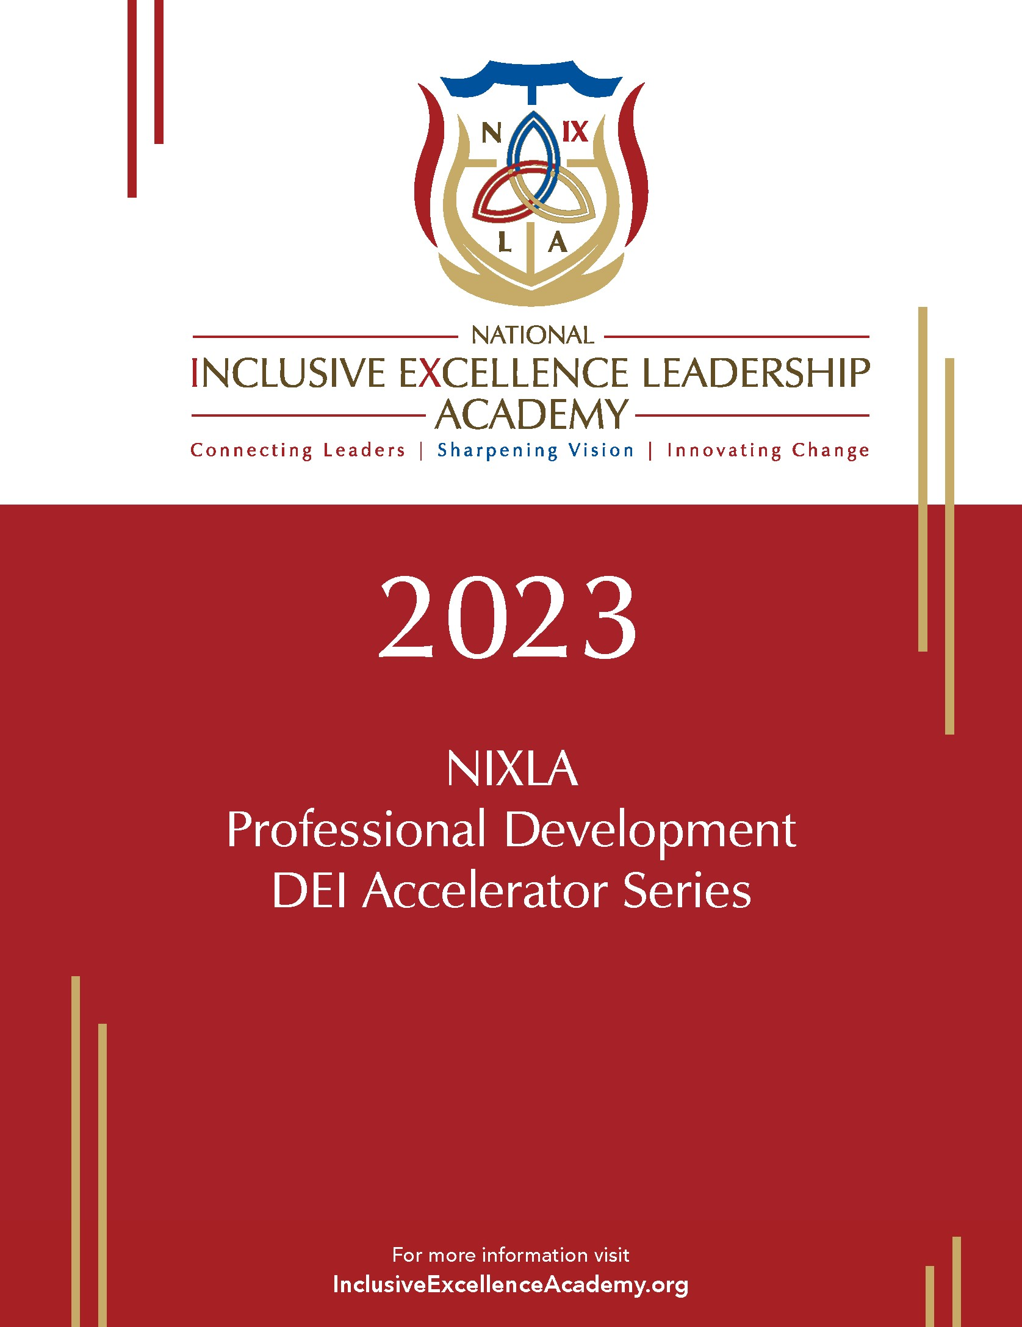
APPENDIX 1: NIXLA PROGRAM BROCHURE

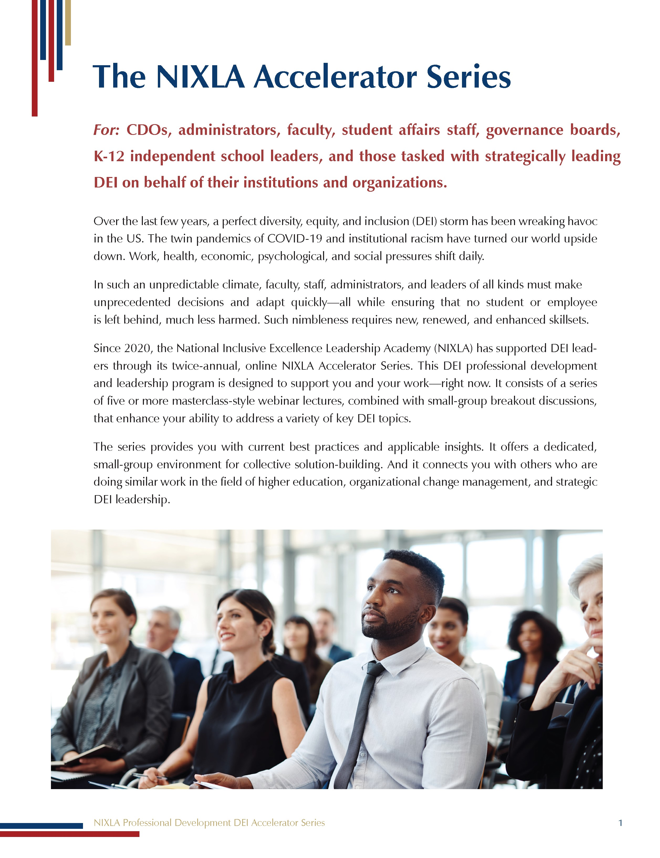
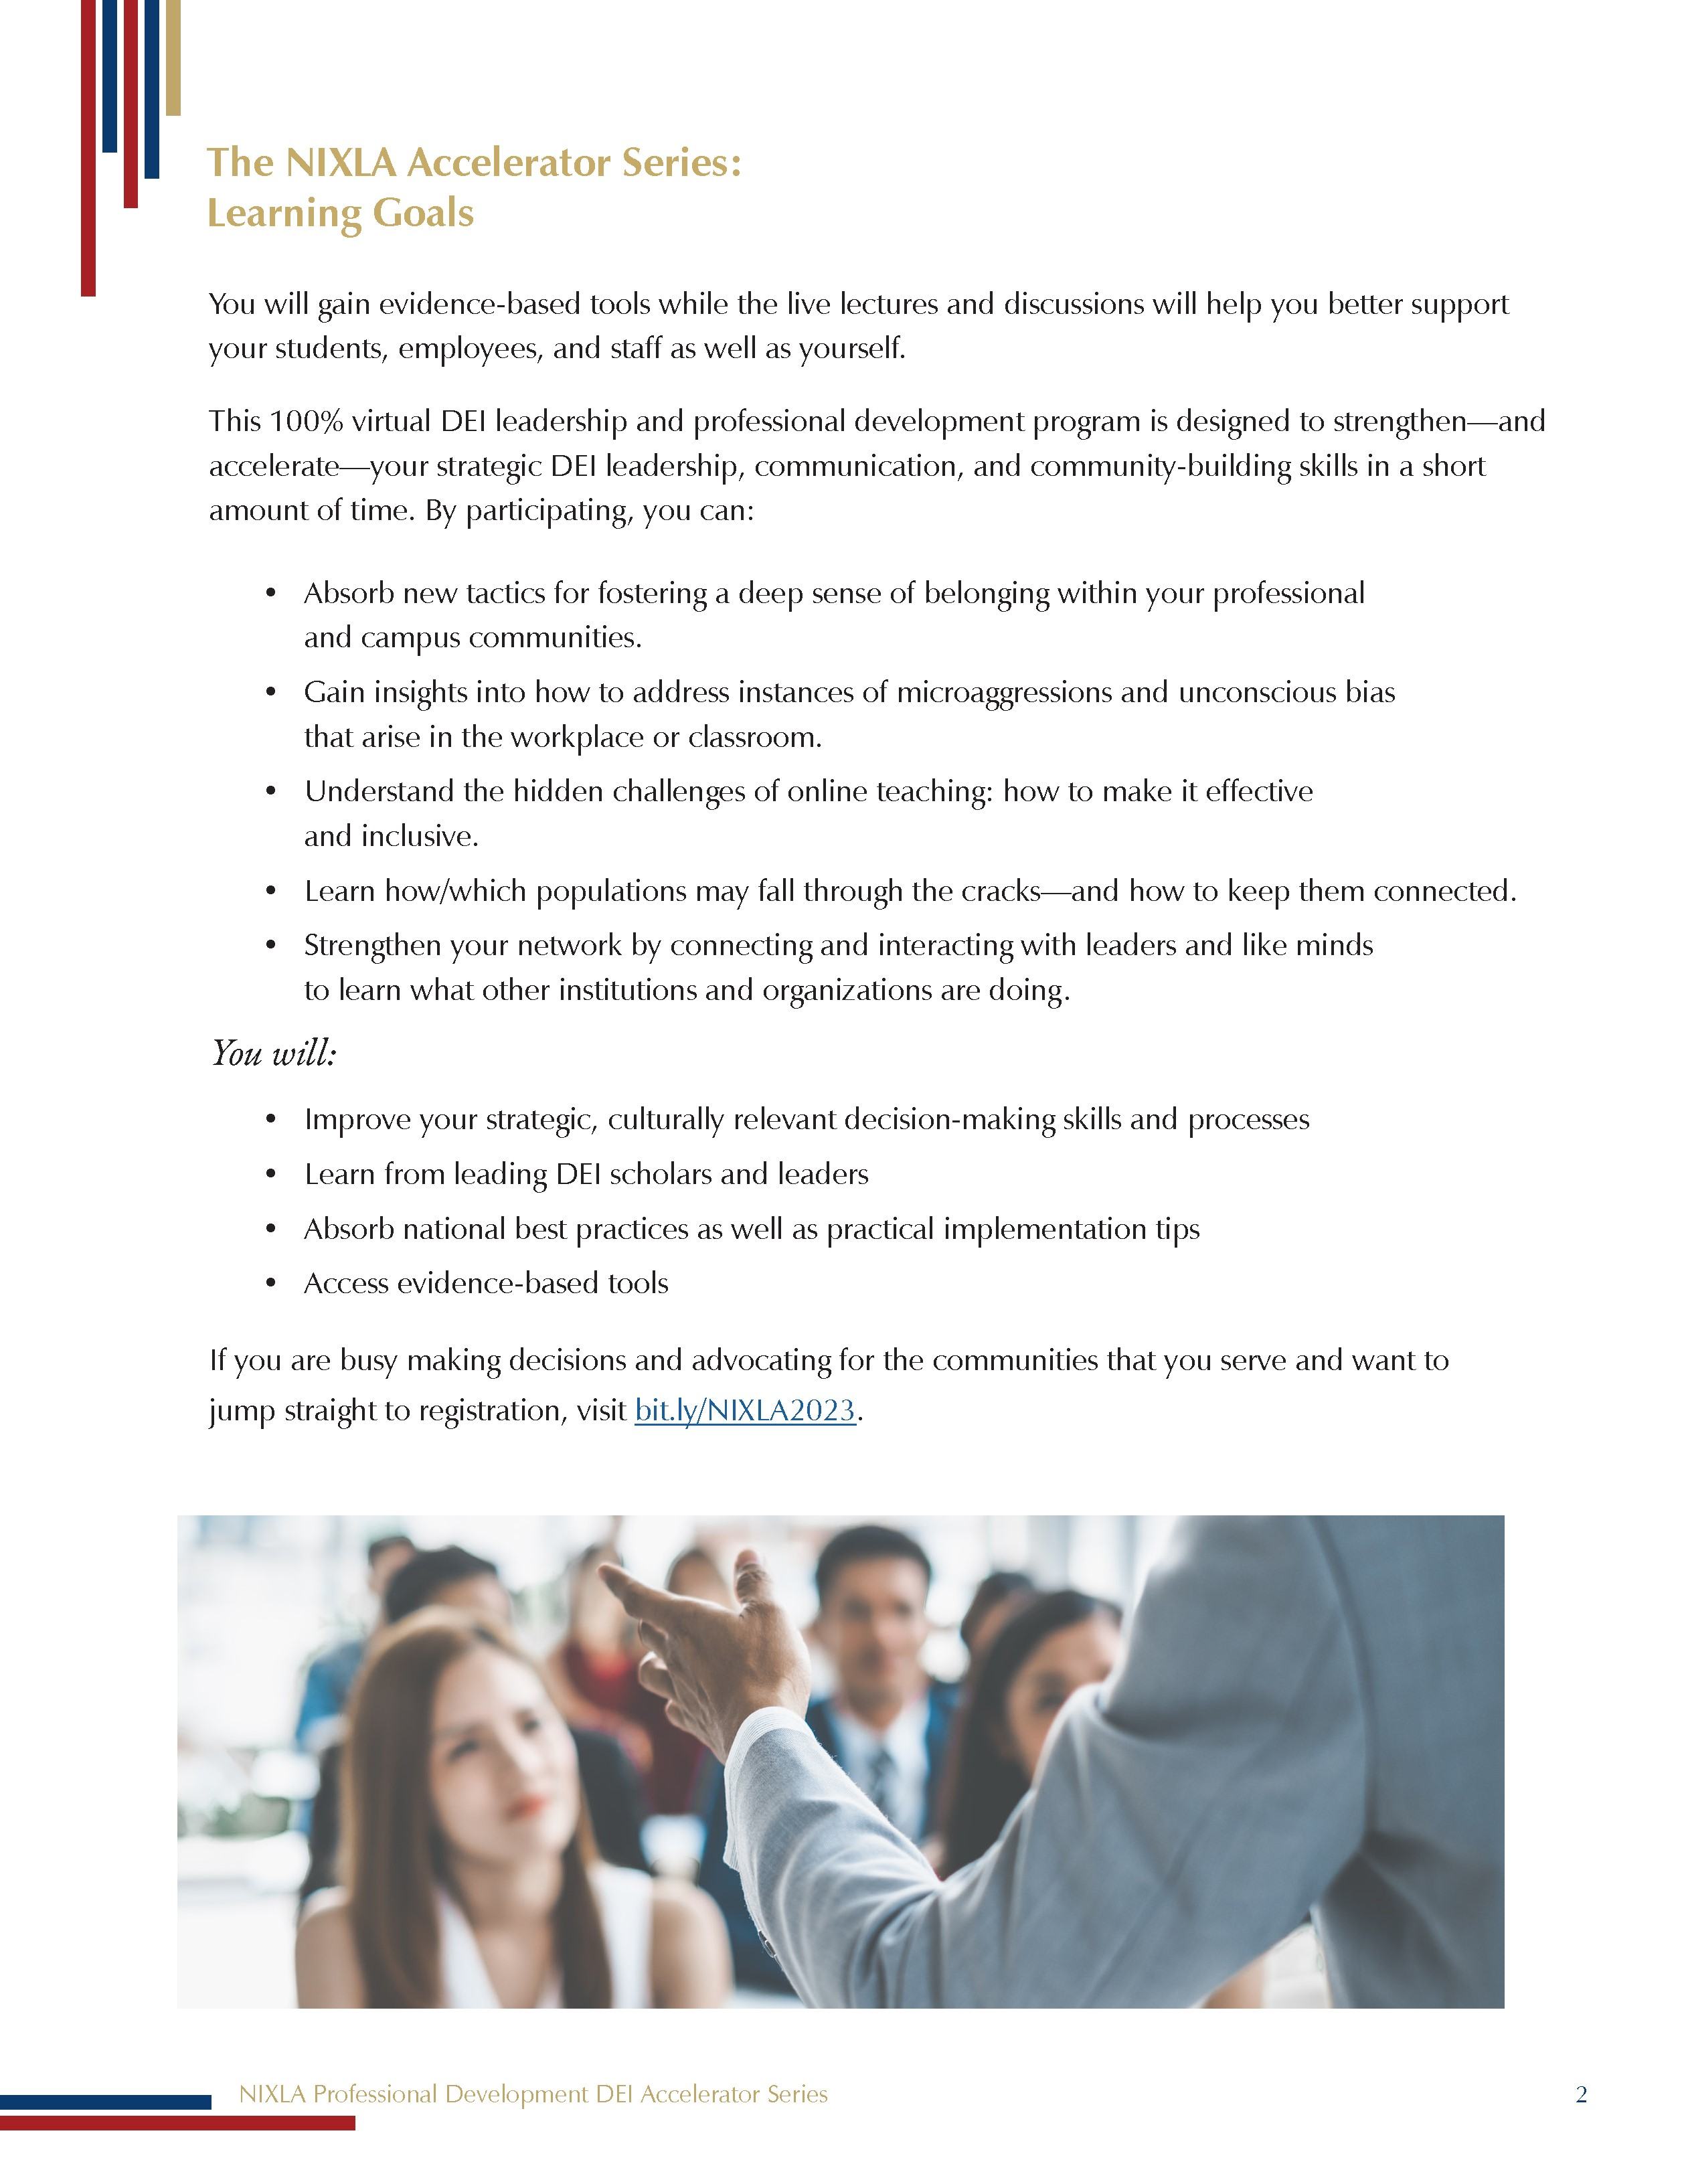
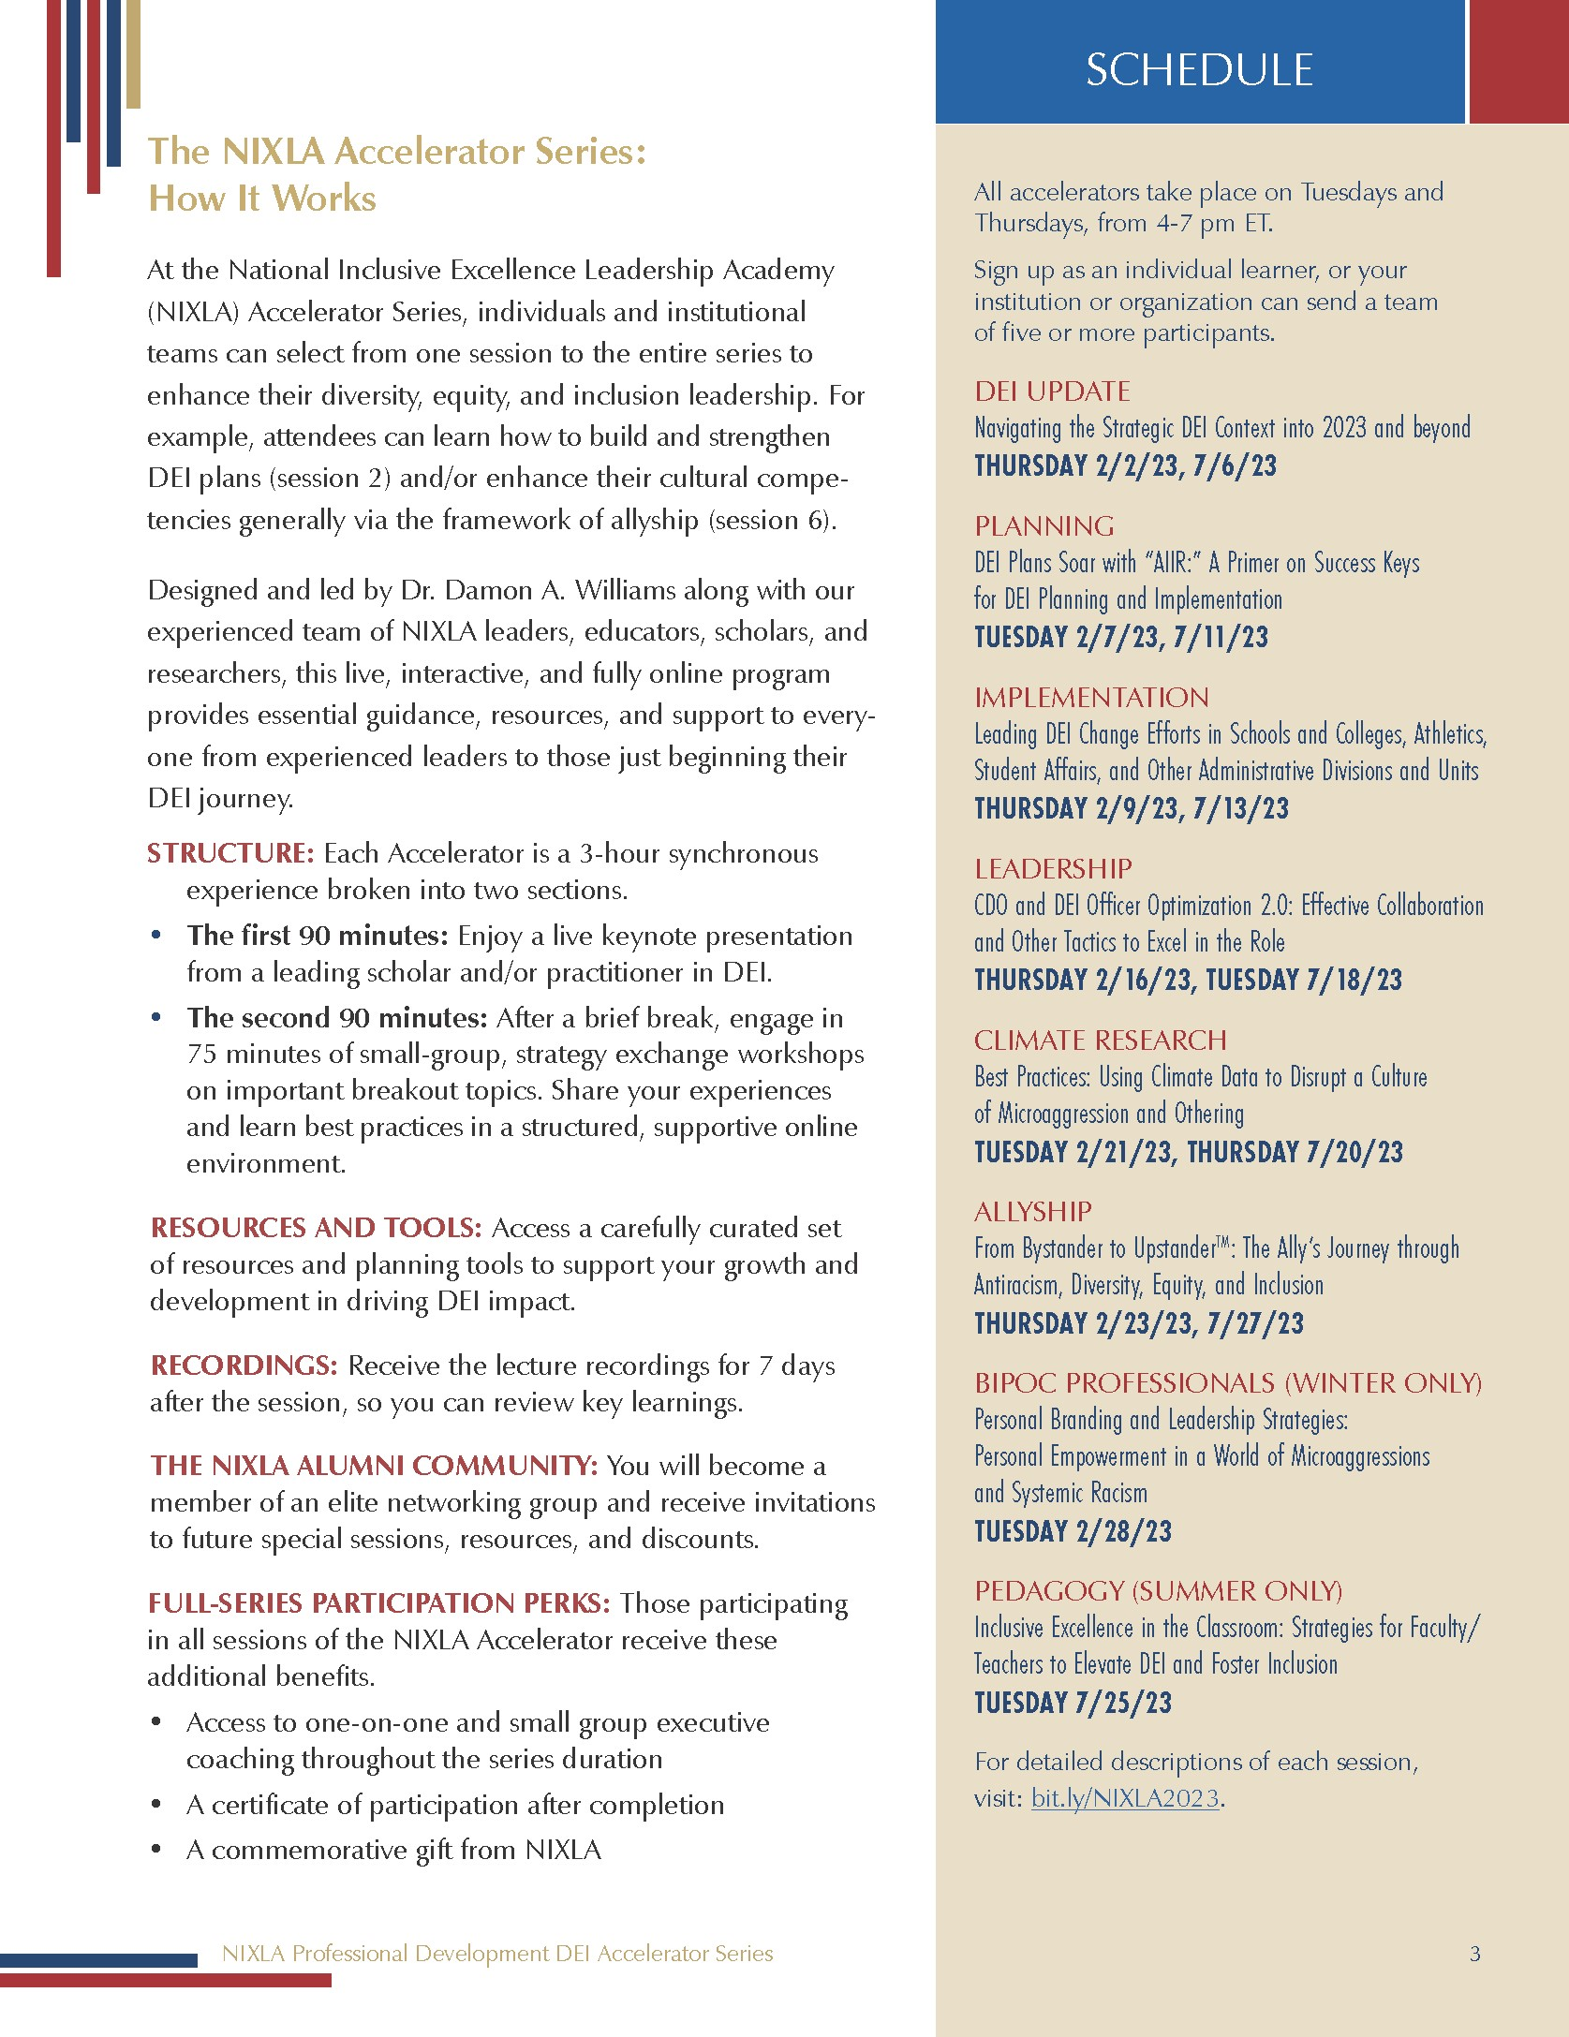
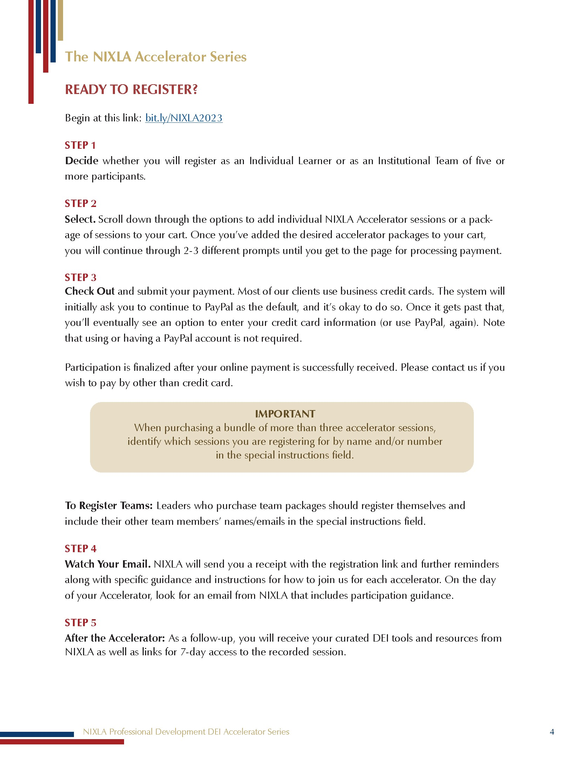
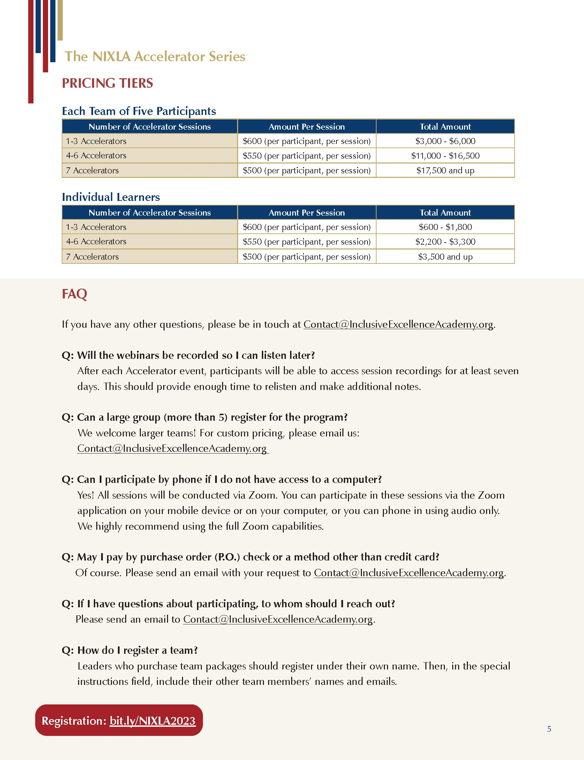
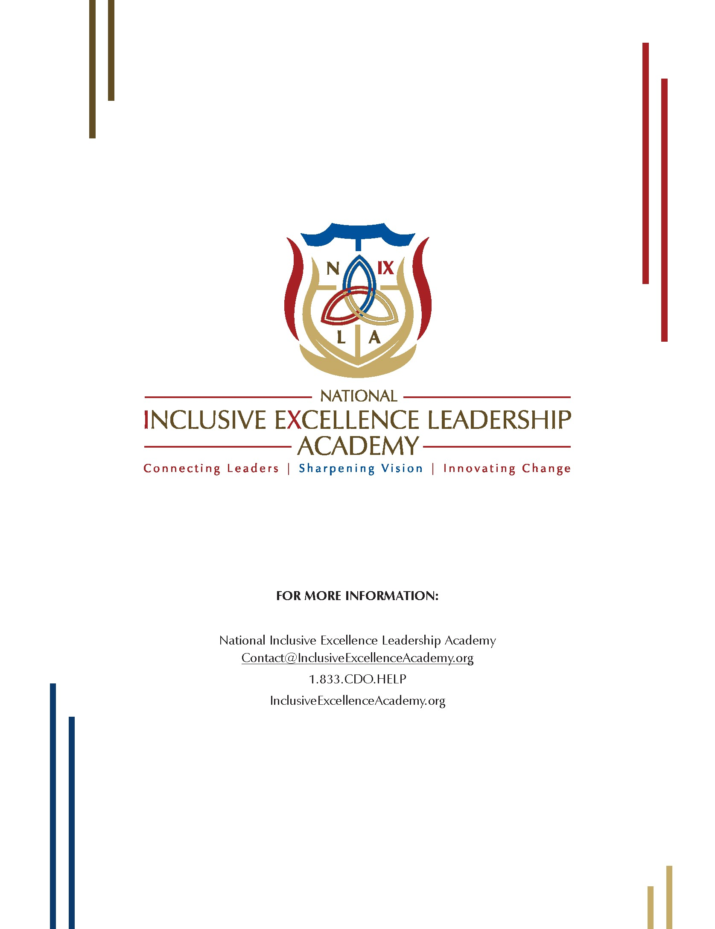

APPENDIX 2: NIXLA INFORMATIONAL SLIDES
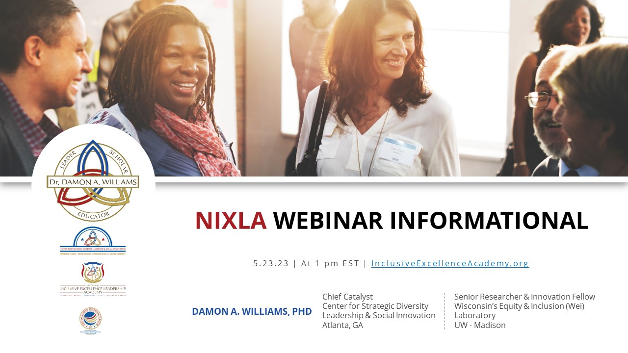
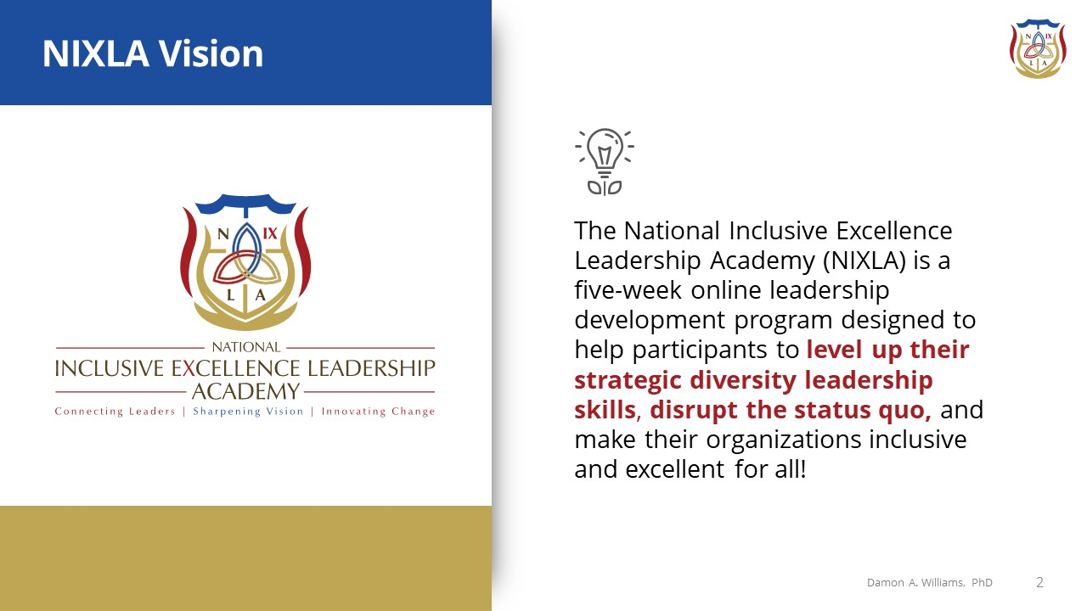

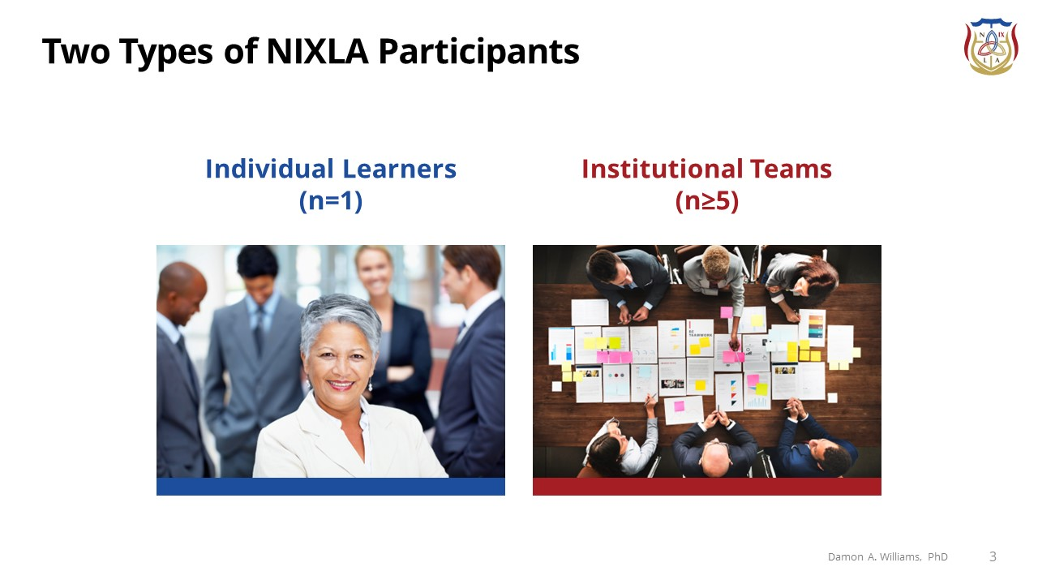
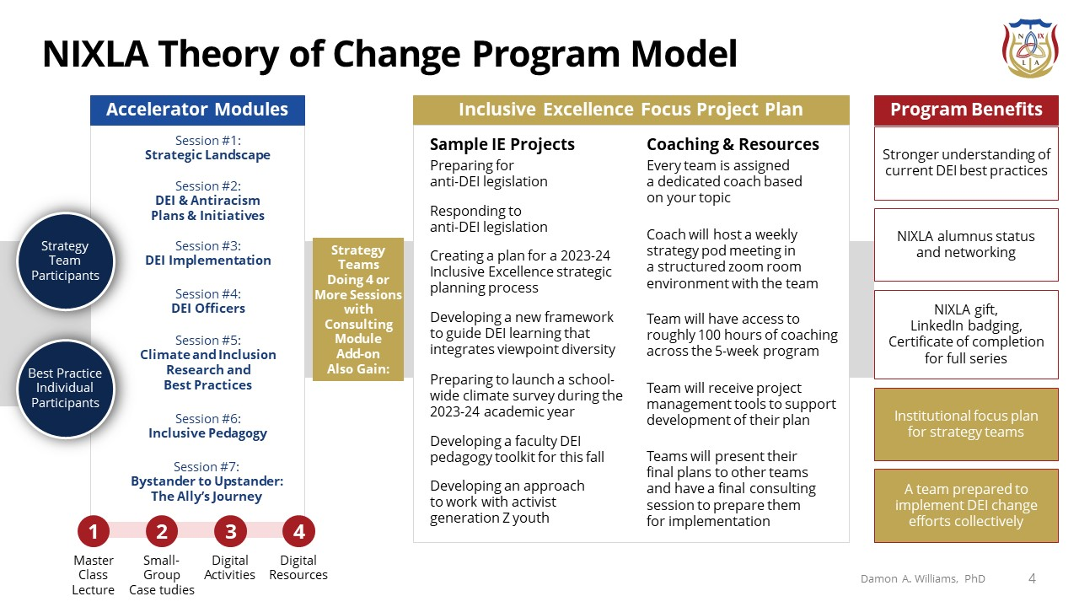

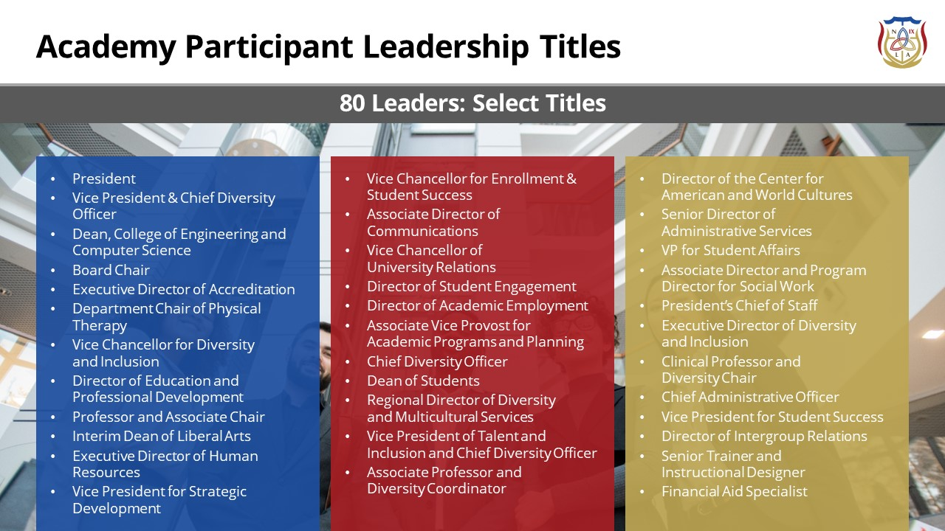
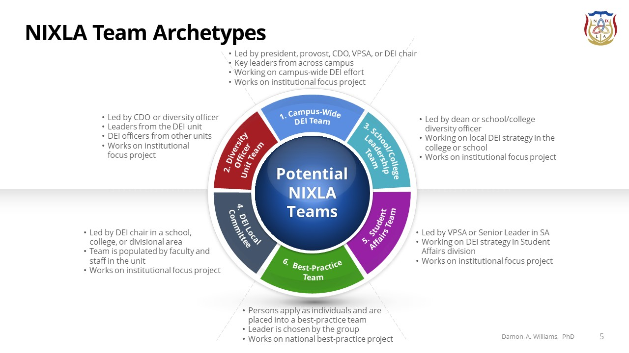

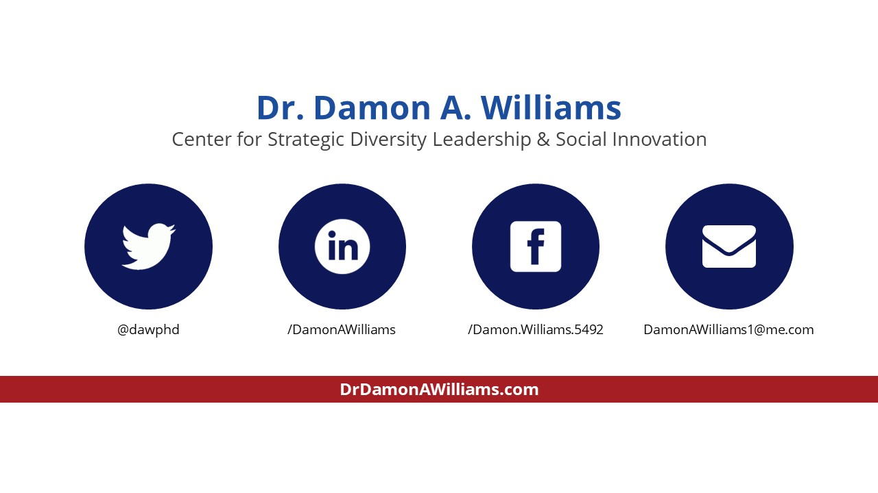
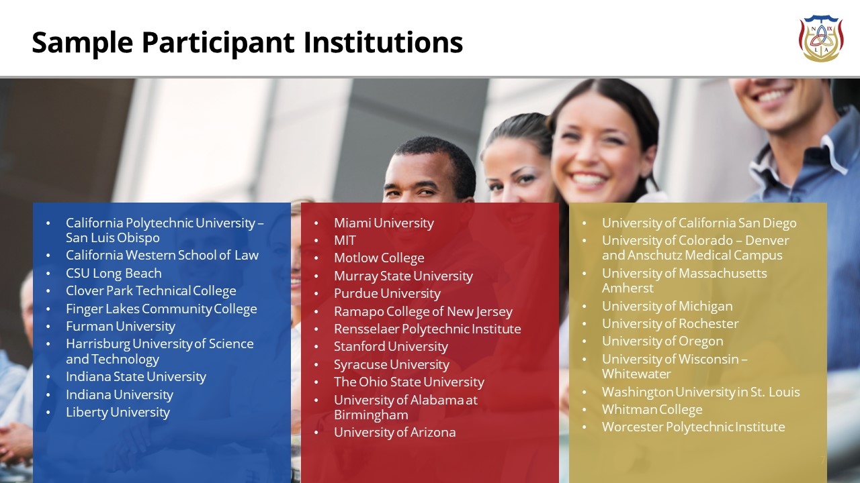

Attending as a team of five allows us to tap into substantive cost savings for the Accelerator program. If our team includes more than five, the price per attendee would drop further.
The NIXLA Focus Project consulting support is only available for those teams participating in a minimum of four Accelerator sessions.
Attending the complete series (all seven master-class Accelerator sessions) allows us to tap into substantive cost savings.

